
Bahria University, Lahore Campus
Department of Computer Science
Lab Journal 09
(Fall 2025)

Course: | Introduction to Data Science - Lab | Date: _______________
Course Code: | CSL-487 | Max Marks: 20
Faculty’s Name: | Mr. Muhammad Umar Tariq

Name: Khawaja Fahad Zia Enroll No: 03-134221-057 Class: BSCS-6A

Objective(s):
Upon completion of this lab session, learners will be able to:
- To understand and preprocess a real-world regression dataset including handling missing values, encoding categorical variables, and applying feature scaling.
- To perform Exploratory Data Analysis (EDA) and identify key factors that influence used car prices through visual and statistical methods.
- To train and compare regression models such as Linear Regression and Random Forest for predicting car prices.
- To evaluate model performance using standard metrics including MAE, MSE, RMSE, and R² score.
- To make predictions on new manually entered car data and save the trained model, encoder, and scaler for deployment and future use.

Lab Tasks:

Task 1: Car Price Prediction (Regression Task)
Scenario:
You have recently joined an automobile analytics company named "AutoValue Motors" as a Junior Data Scientist.
Your first assignment is to help the company build a model that can predict the resale price of used cars based on different attributes.
You are provided a dataset named:
car_price_dataset
Step 1: Data Loading and Initial Inspection
- Load the dataset into a panda DataFrame.
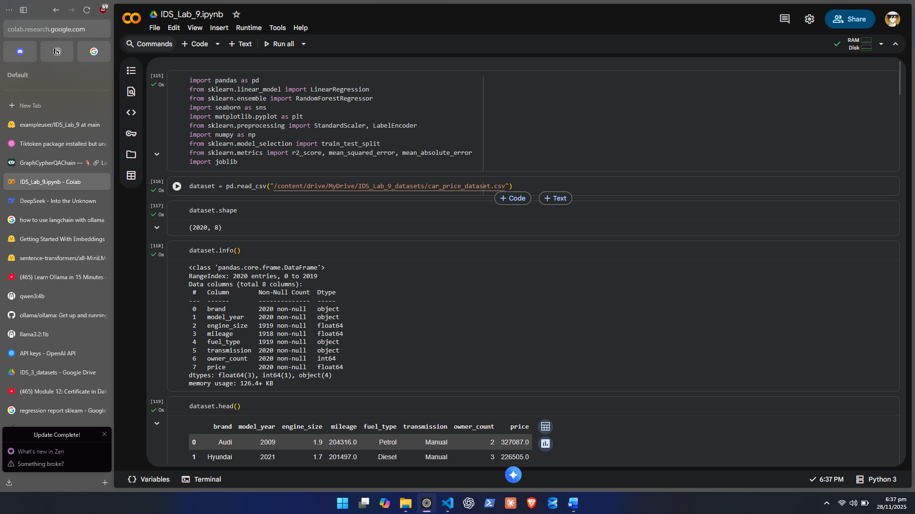
- Display the first 5–10 rows to understand the structure.
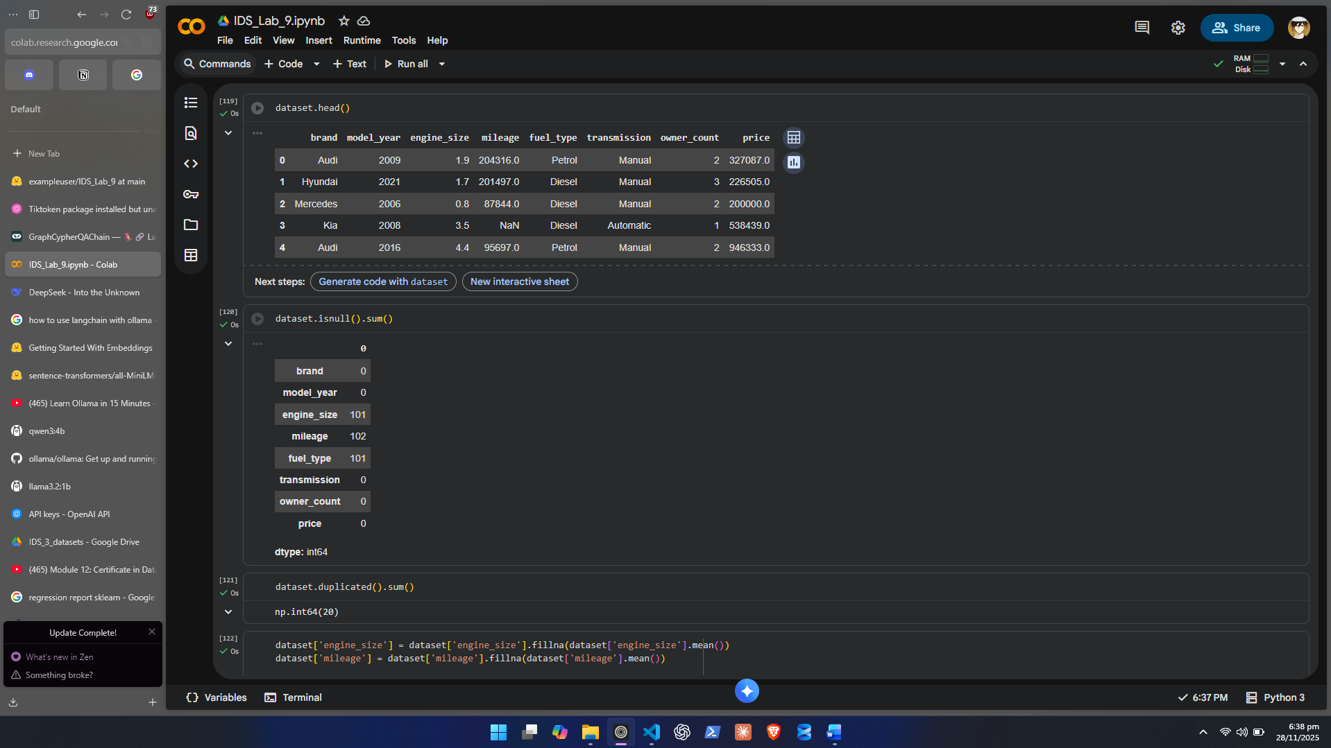
- Check:
  - Shape
  - Column names
  - Data types
  - Missing values
  - Duplicate entries
- Write a short initial observation summary.

Step 2: Data Preprocessing
Perform complete preprocessing:
- Handling Missing Values
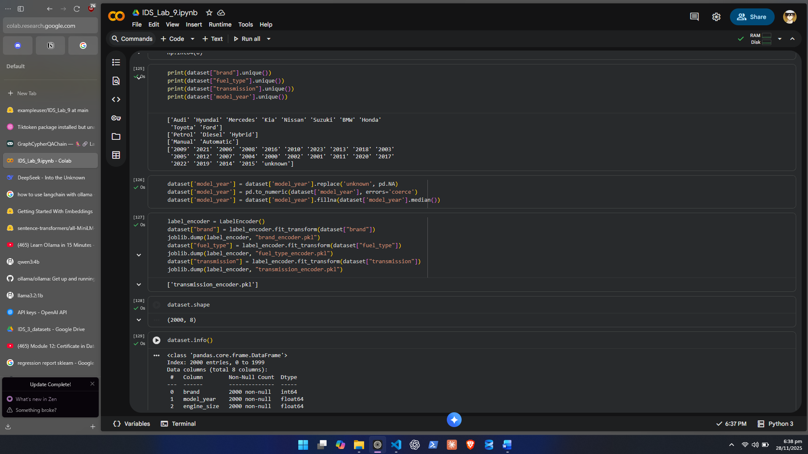
- Duplicate Handling
- Encoding Categorical Features
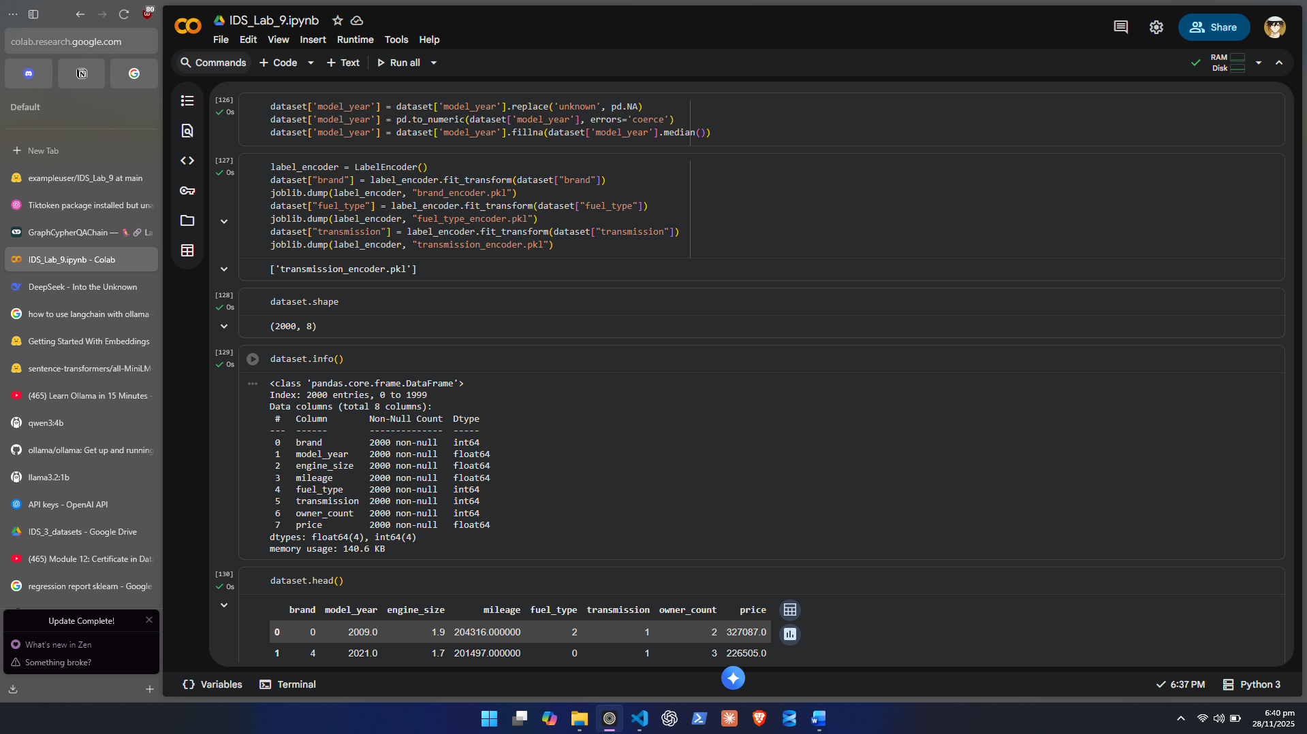
- Feature Scaling
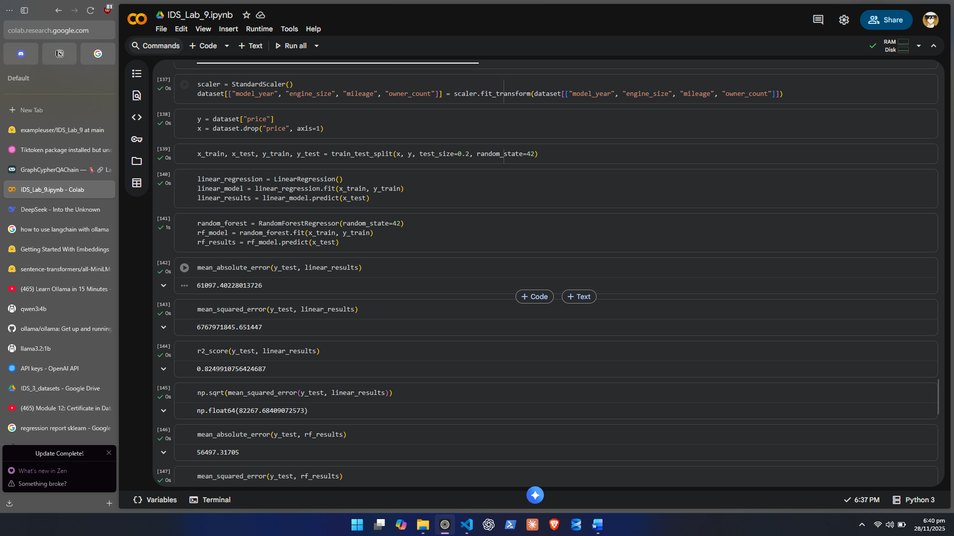
Step 3: Exploratory Data Analysis (EDA)
3.1 Target Variable Distribution
- Plot histogram + KDE for Selling Price.
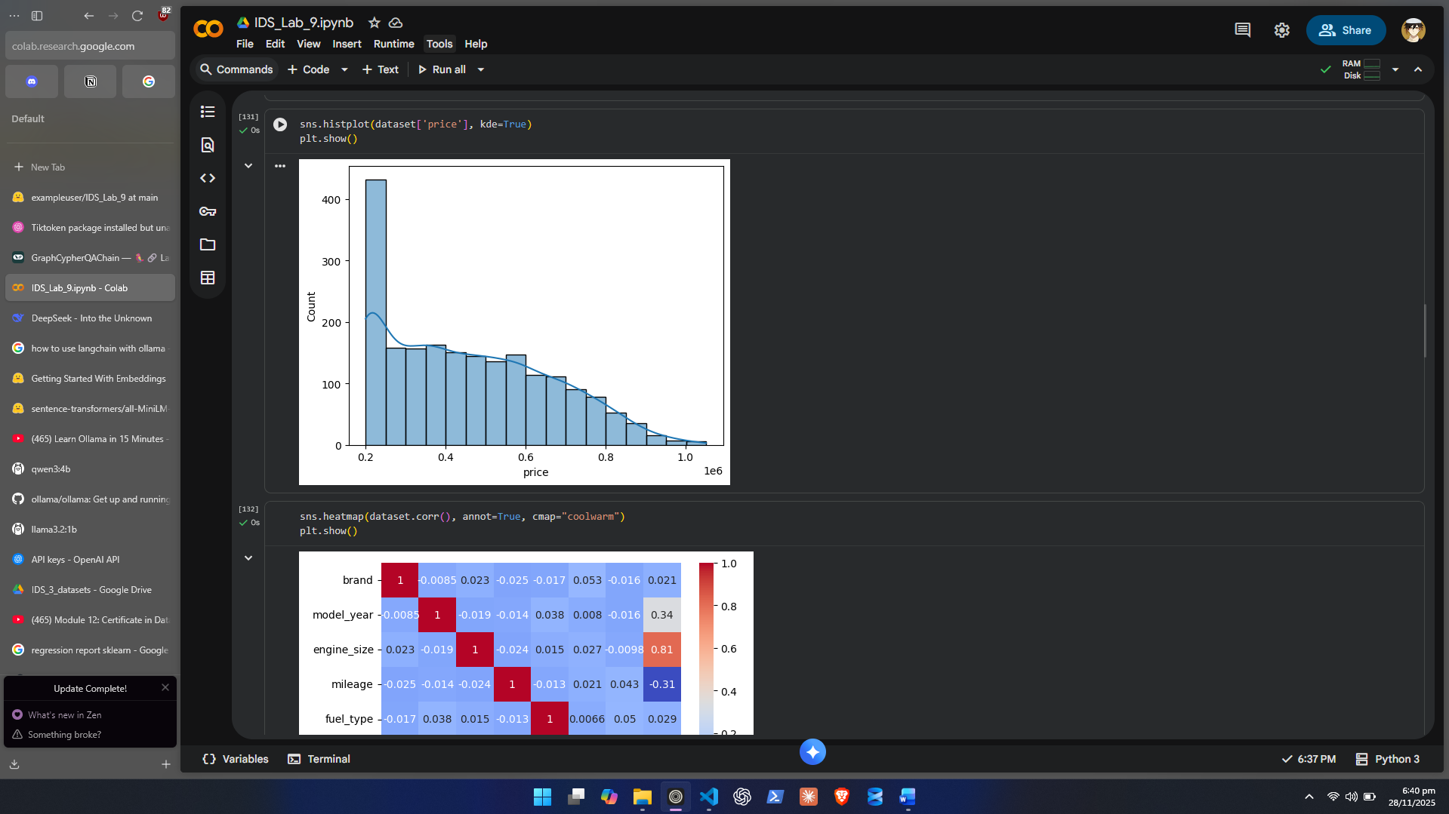
3.2 Correlation Analysis
- Create a correlation heatmap for numerical variables.
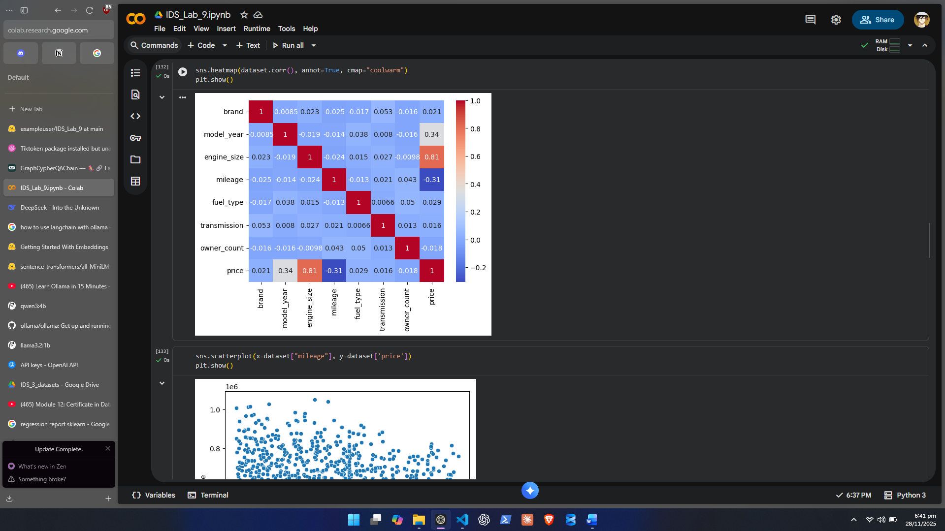
3.3 Relationship Visualizations
Use scatterplots for:
- Mileage vs Selling Price
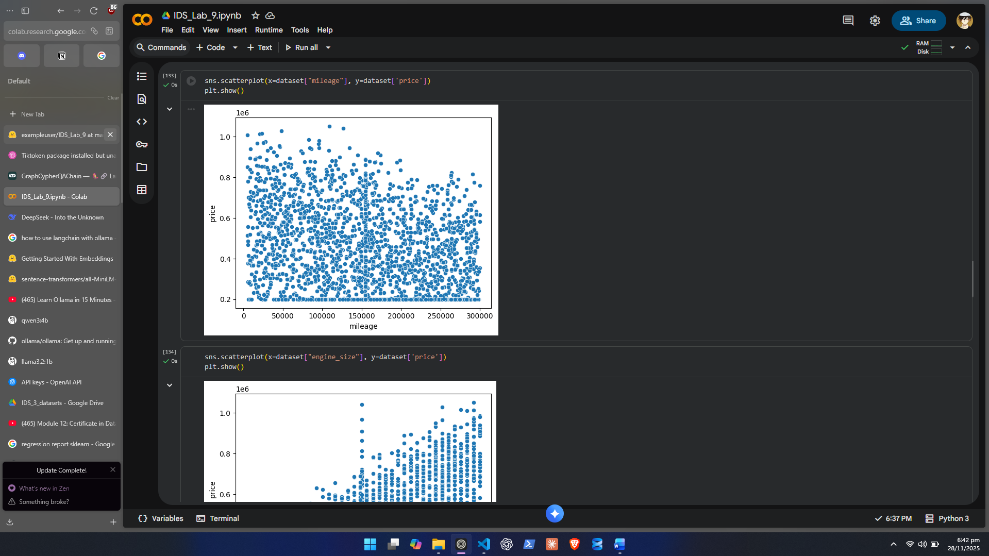
- Engine Size vs Selling Price
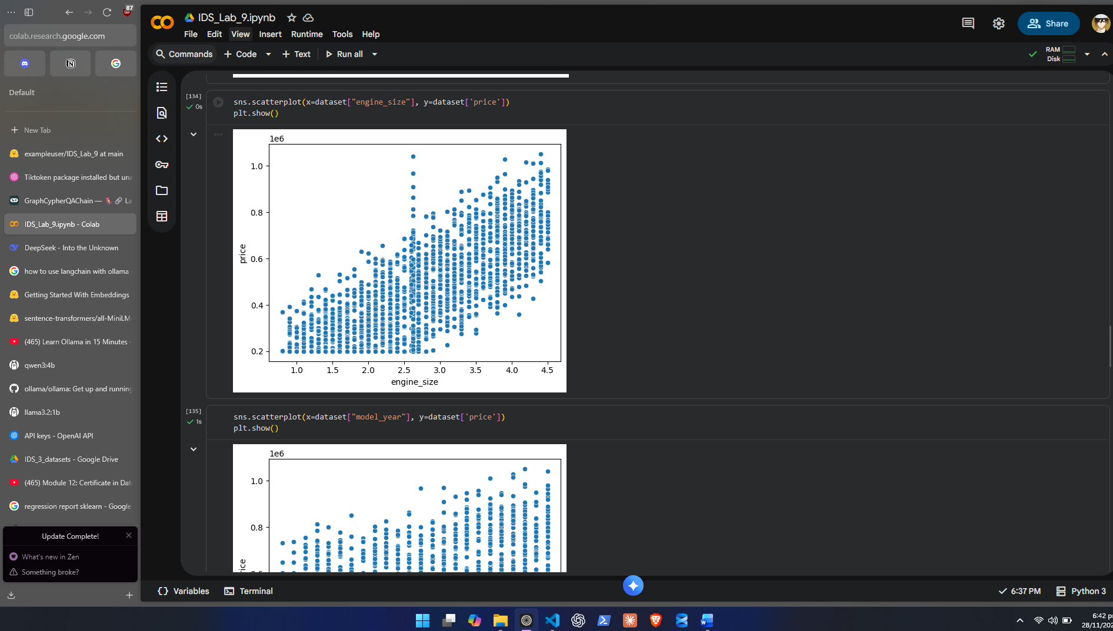
- Model Year vs Selling Price
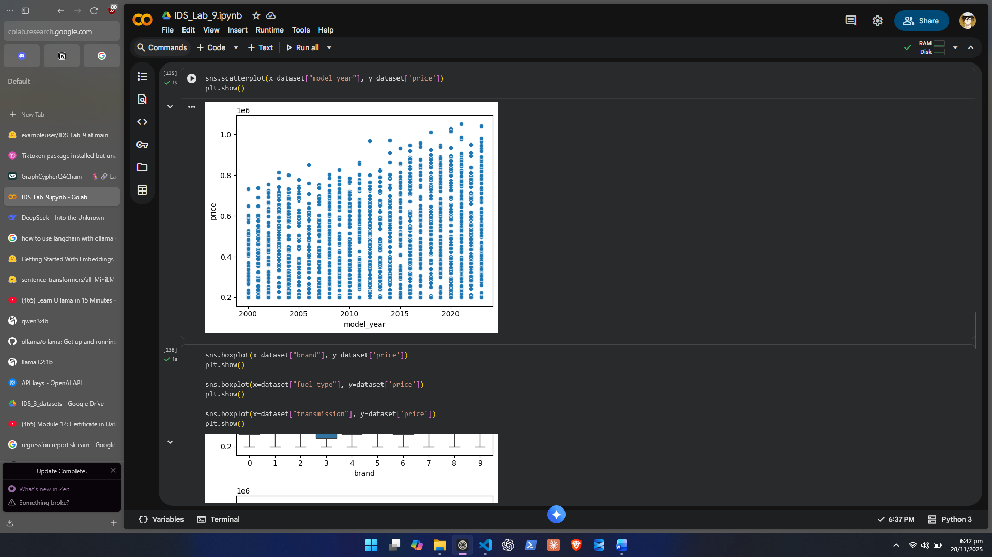
3.4 Categorical Analysis
Use boxplots/violin plots:
- Brand vs Price
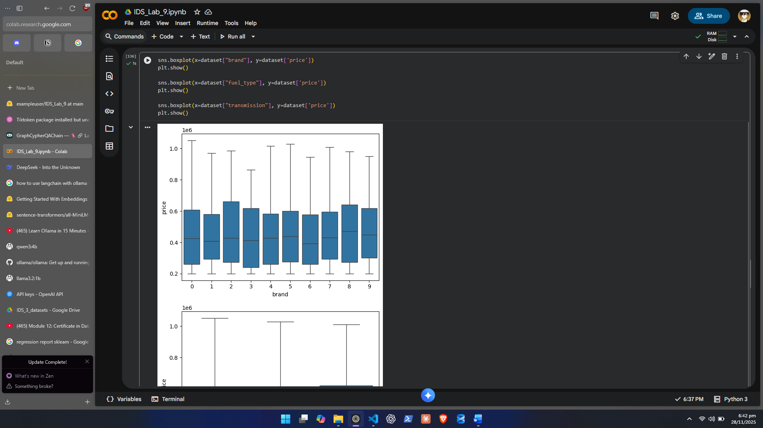
- Fuel Type vs Price
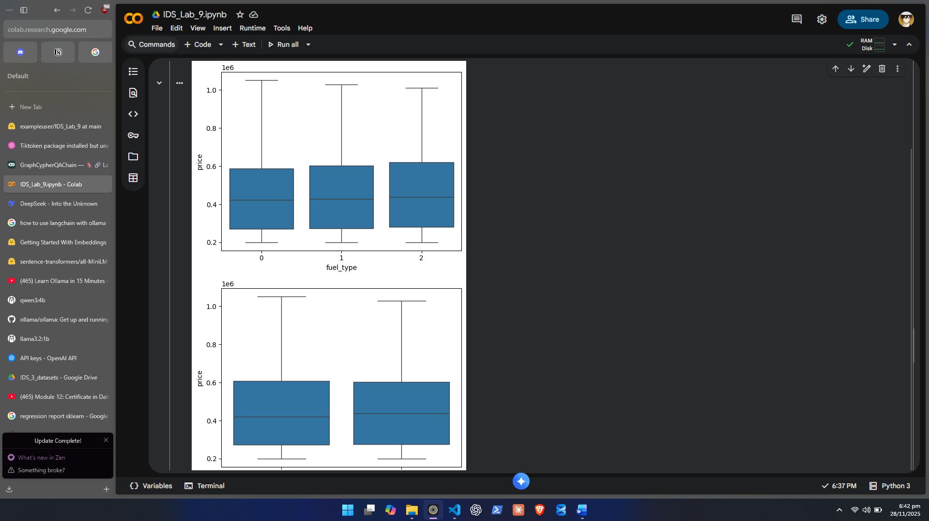
- Transmission vs Price
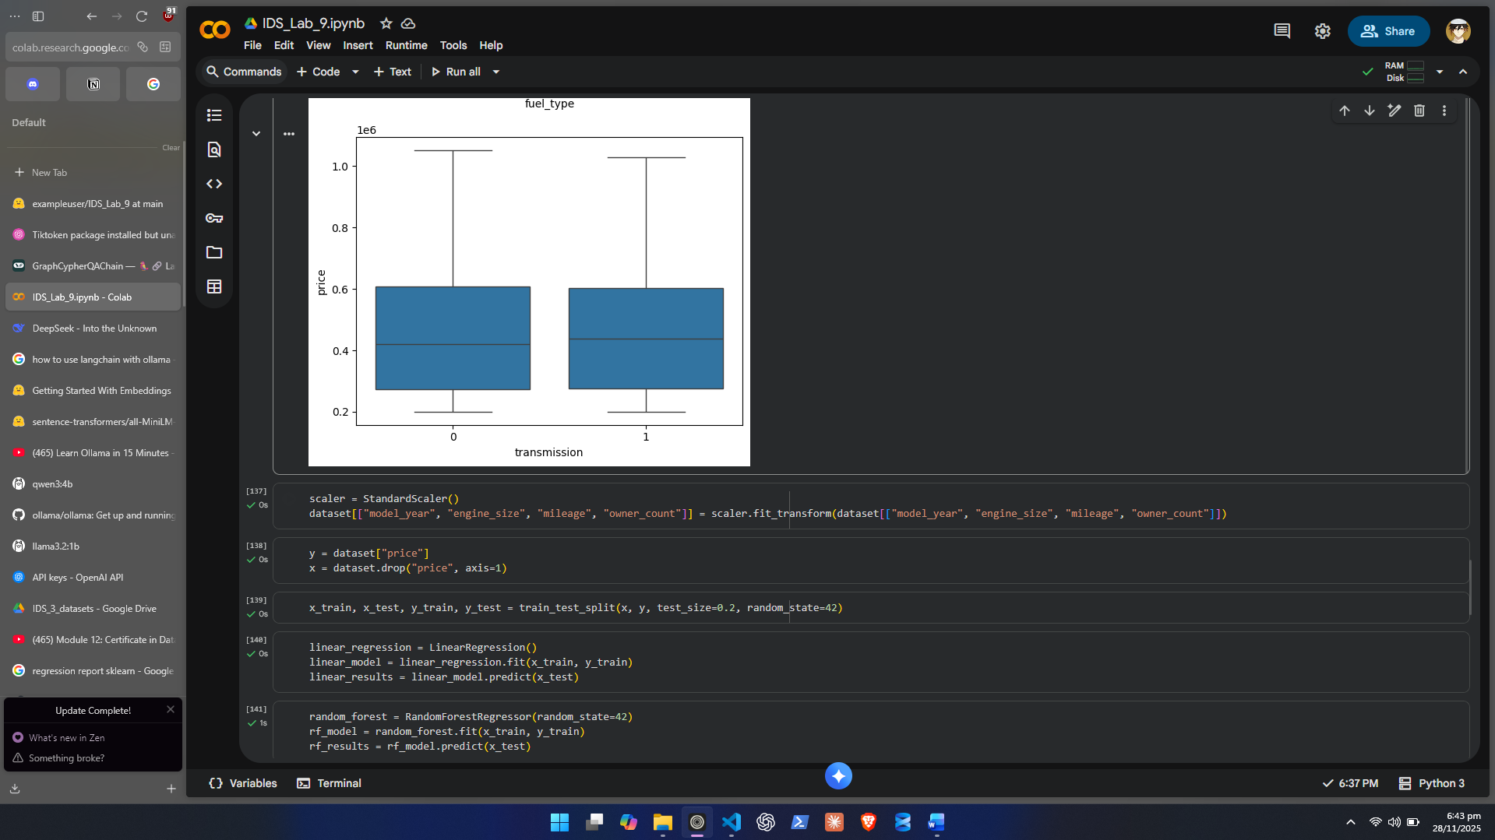
Step 4: Data Splitting and Model Training
4.1 Feature-Target Split
- X = all independent variables
- y = SellingPrice
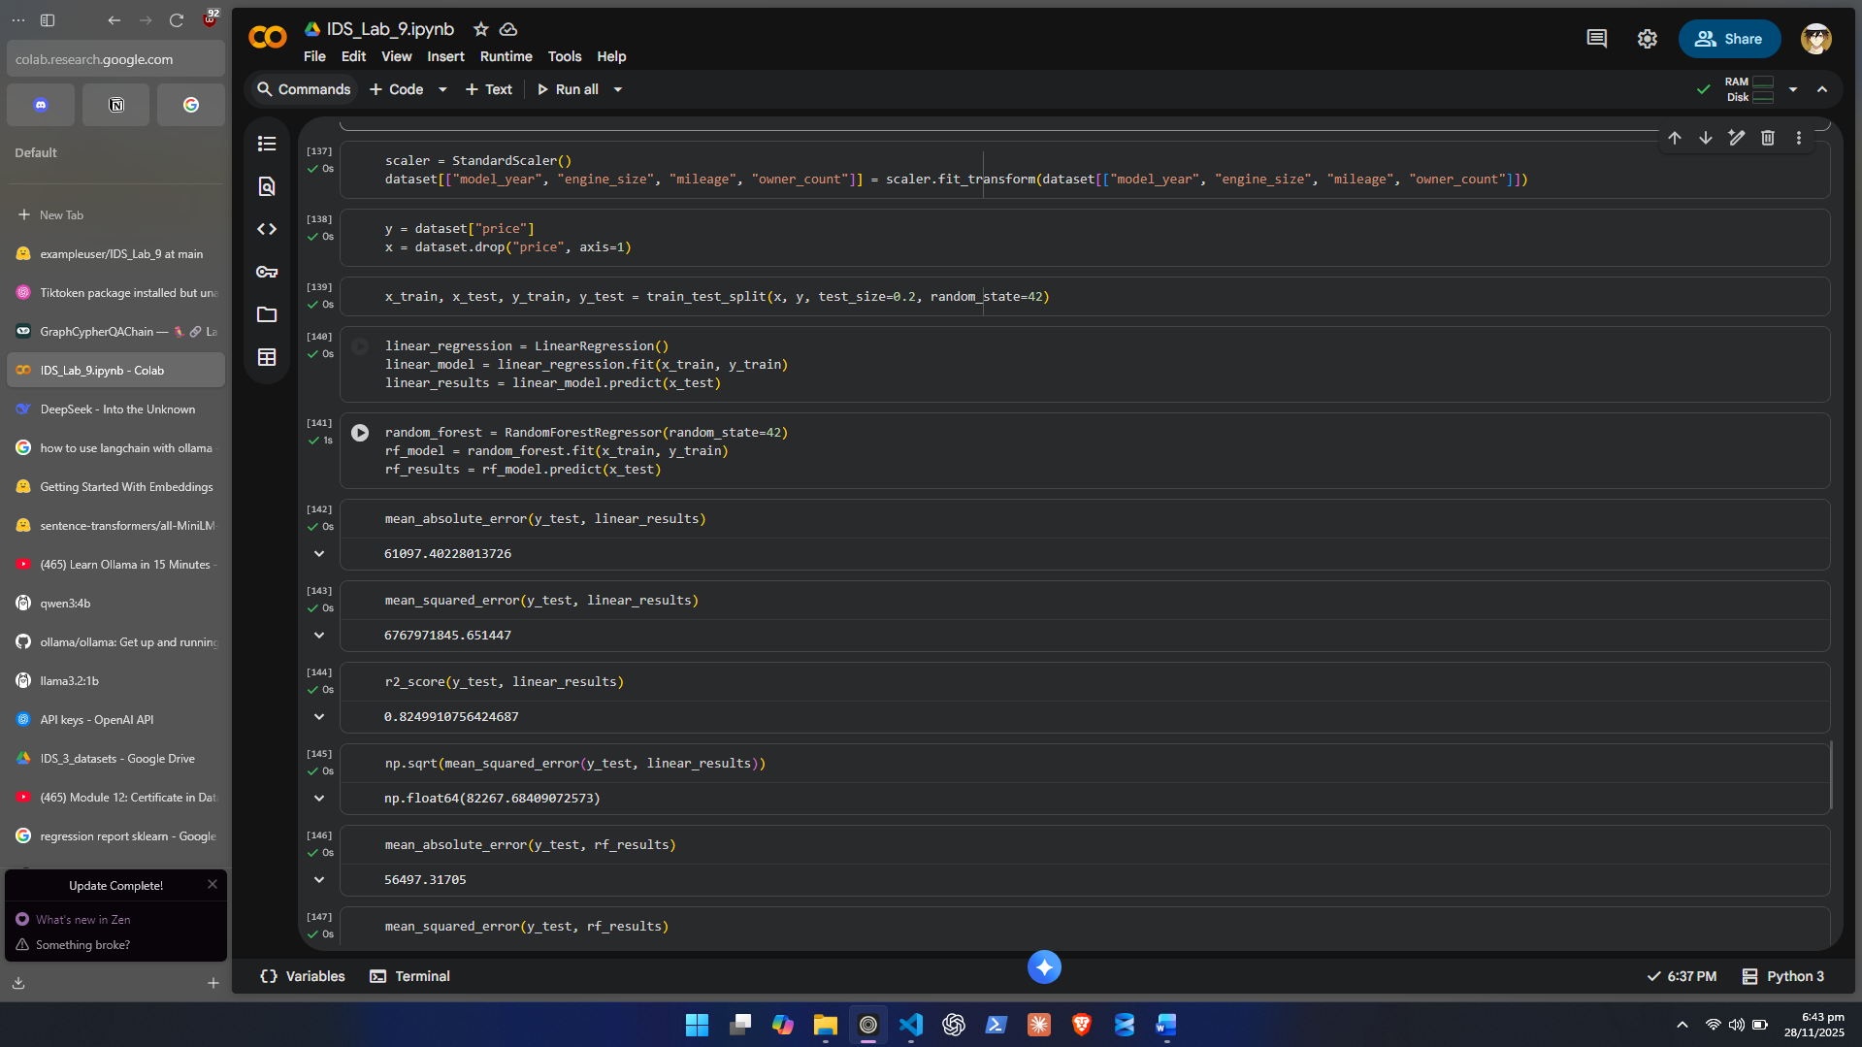
4.2 Train-Test Split
- 80% Training
- 20% Testing
4.3 Train at Least Two Regression Models
Minimum required:
- Linear Regression
- Random Forest Regressor
Students may try others (optional):
- Gradient Boosting
- XGBoost
4.4 Evaluate Each Model
Compute:
- R² Score
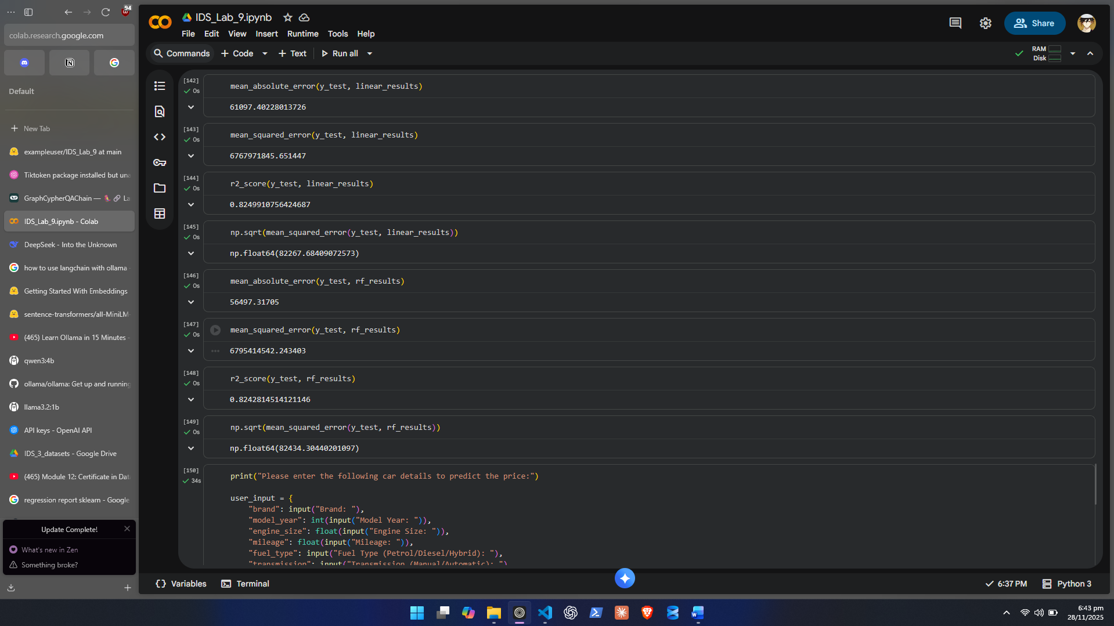
- Mean Absolute Error (MAE)
- Mean Squared Error (MSE)
- Root Mean Squared Error (RMSE)

Step 5: Testing the Model on New Input Data
In this step, students will manually enter custom car details and predict its price.
5.1 Create a Dictionary for New Input
Ask the user for:
- Brand
- Model Year
- Engine Size
- Mileage
- Fuel Type
- Transmission
- Owner Count
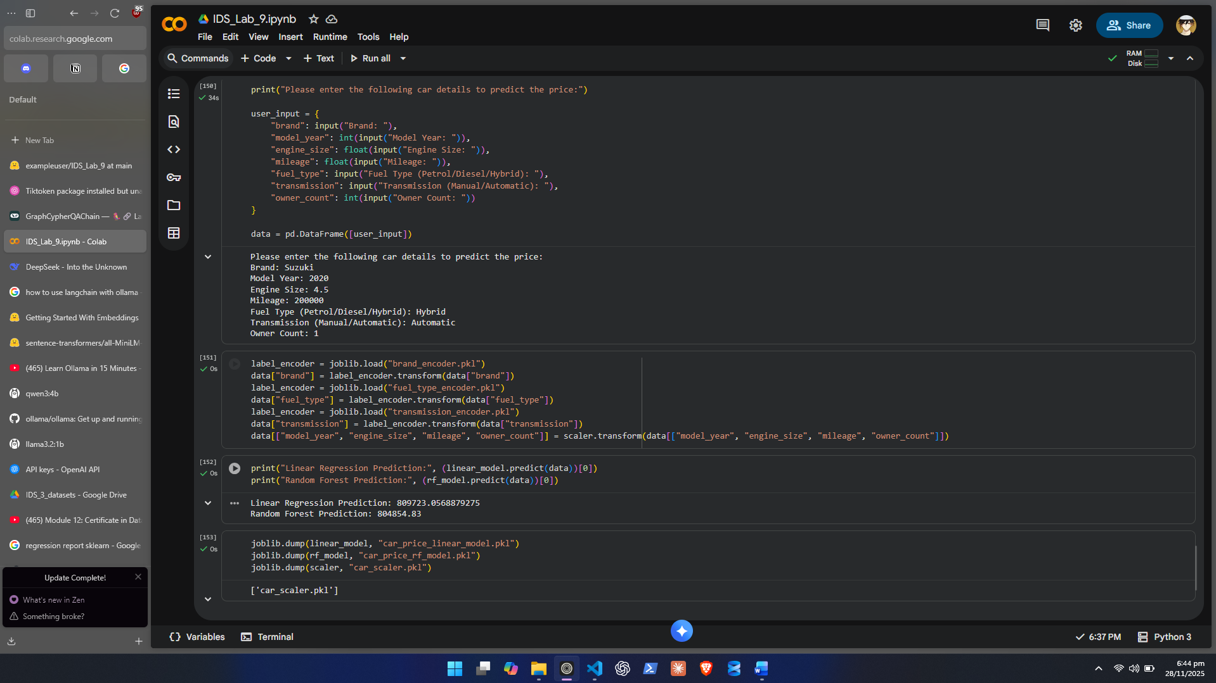
5.2 Convert Input Into a DataFrame
Ensure the structure matches training features.

5.3 Apply the Same Preprocessing
- Encode using the SAME encoder
- Scale using the SAME scaler
5.4 Predict Using the Trained Model
model.predict(new_data)
Print the predicted selling price.
Step 6: Saving the Trained Model
Students must save:
- The trained regression model
- The encoder(s)
- The scaler

Task 2: Hugging Face Space + Gradio

You upload your model + scaler + encoder to Hugging Face, then create a simple interactive frontend (HTML-like UI) automatically.
Folder Structure
/space
├── app.py
├── car_price_model.pkl
├── scaler.pkl
├── encoder.pkl
├── requirements.txt

Step 1 — Make requirements.txt
gradio
scikit-learn
pandas
numpy
joblib

Step 2 — Create app.py

import gradio as gr
import pandas as pd
import joblib

# Load saved model + preprocessing
model = joblib.load("car_price_model.pkl")
scaler = joblib.load("scaler.pkl")
encoder = joblib.load("encoder.pkl")

# Function to predict
def predict_price(brand, model_year, engine_size, mileage, fuel_type, transmission, owner_count):
# Create dataframe exactly like training
df = pd.DataFrame([{
"brand": brand,
"model_year": model_year,
"engine_size": engine_size,
"mileage": mileage,
"fuel_type": fuel_type,
"transmission": transmission,
"owner_count": owner_count
}])

# Apply encoding
df_encoded = encoder.transform(df)

# Apply scaling
df_scaled = scaler.transform(df_encoded)

# Predict
price = model.predict(df_scaled)[0]
return f"Predicted Price: Rs {price:,.0f}"

# Gradio UI
ui = gr.Interface(
fn=predict_price,
inputs=[
gr.Dropdown(["Toyota","Honda","Suzuki","Hyundai","Kia","BMW","Audi","Mercedes","Ford","Nissan"], label="Brand"),
gr.Number(label="Model Year"),
gr.Number(label="Engine Size"),
gr.Number(label="Mileage"),
gr.Dropdown(["Petrol","Diesel","Hybrid"], label="Fuel Type"),
gr.Dropdown(["Automatic","Manual"], label="Transmission"),
gr.Number(label="Owner Count"),
],
outputs=gr.Textbox(),
title="Car Price Prediction System",
description="Predict used car prices using your ML model."
)

ui.launch()

Step 3 — Upload to Hugging Face Space
- Go to: https://huggingface.co/spaces
- Click New Space
- Select Gradio
- Upload all files
- Space automatically runs and generates a clean frontend.

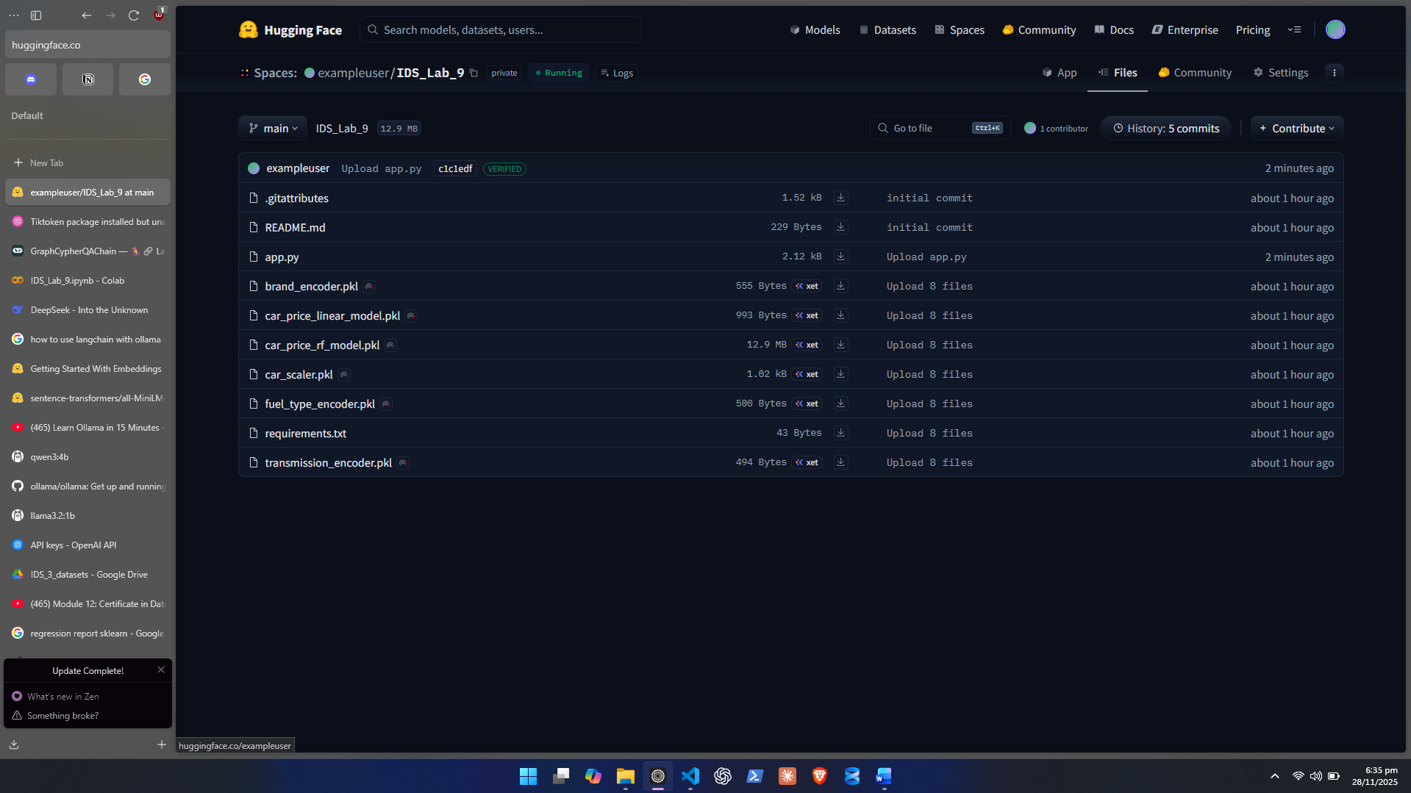
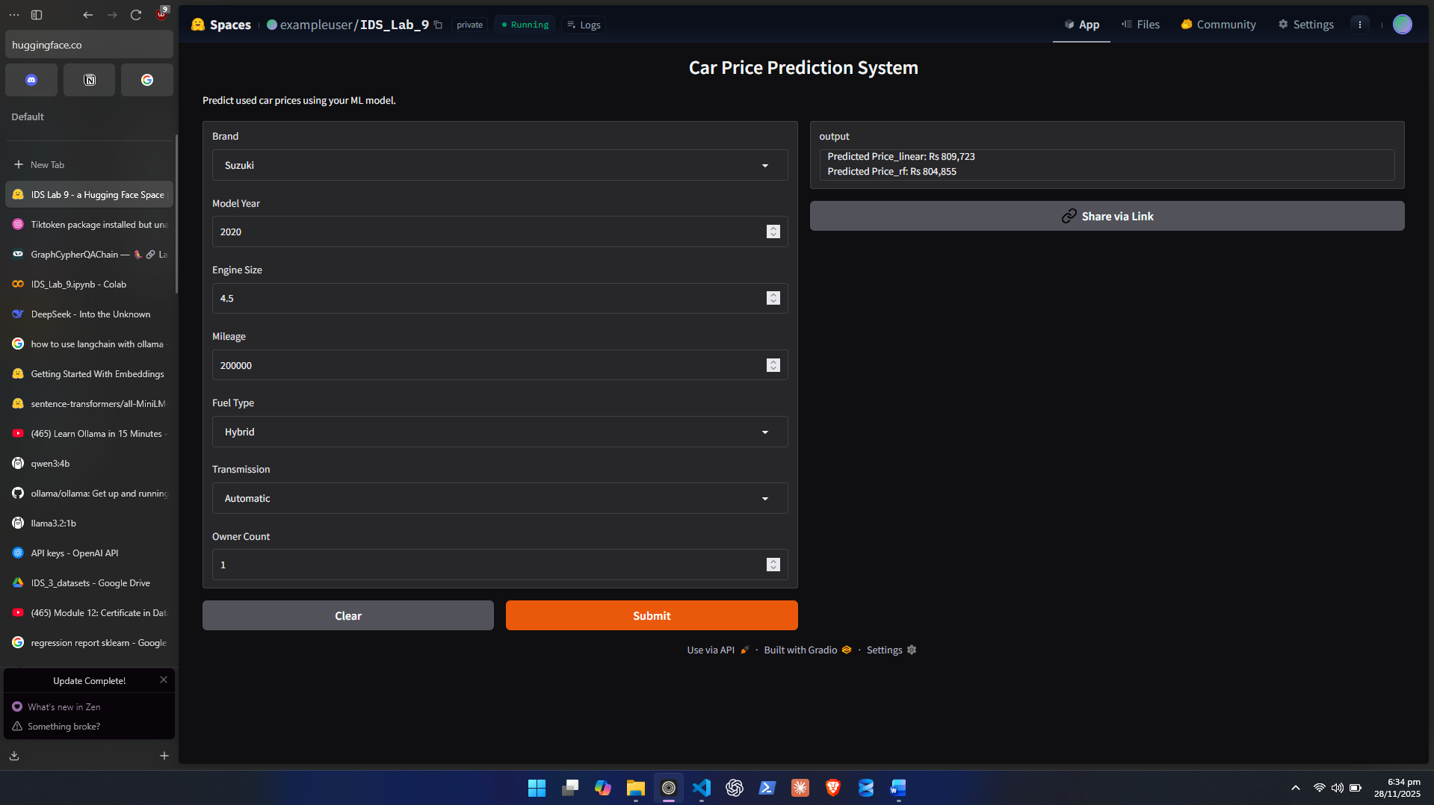

FINAL RESULT
You get a public web link like:
https://huggingface.co/spaces/yourname/car-price-model

Lab Grading Sheet:
Task | Max Marks | Obtained Marks | Comments(if any)
1. | 20
Total | 20 |  | Signature

Note : Attempt all tasks and get them checked by your Lab Instructor.

